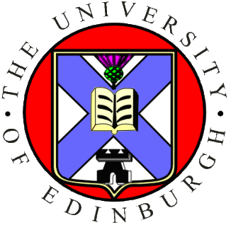 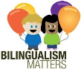

**BILINGUALISM MATTERS @ PENN STATE**

**TRAINING DAY - DECEMBER 10, 2014**

**Antonella Sorace**

**University of Edinburgh and *Bilingualism Matters***

10.00-12.00                  **SESSION 1**: Bilingualism over the lifespan; common misconceptions; benefits and disadvantages; selecting and adapting research findings in linguistics and psychology for non-academic audiences: Room 127 Moore Building

2.00-4.00                  **SESSION 2**: Effective communication; informing people in different sectors of society; frequently asked questions; the bilingualism matters experience in Scotland and Europe; open discussion: Room 127 Moore Building

4:00-4:30 Reception: Moore Building Lobby

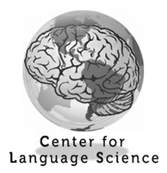

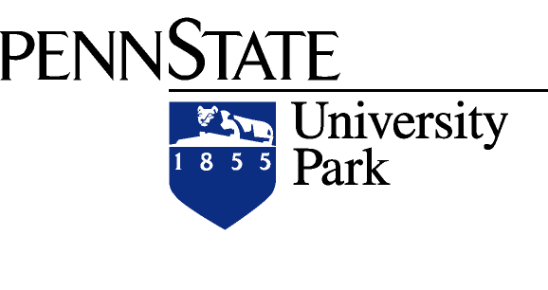

For additional information contact Judith Kroll ([jfk7@psu.edu](mailto:jfk7@psu.edu)) or Sharon Elder ([sle9@psu.edu](mailto:sle9@psu.edu)).